Summary of deliveries and Procedures

- TAL’s Vendor will allocate the PO number to TAL Preferred Courier of their choice
- TAL preferred Courier will book the PO on the SSBS once the physical parcel is received at the depot
- Vendor are NOT allowed to make their own bookings, all PO numbers must be allocated to TAL preferred Courier

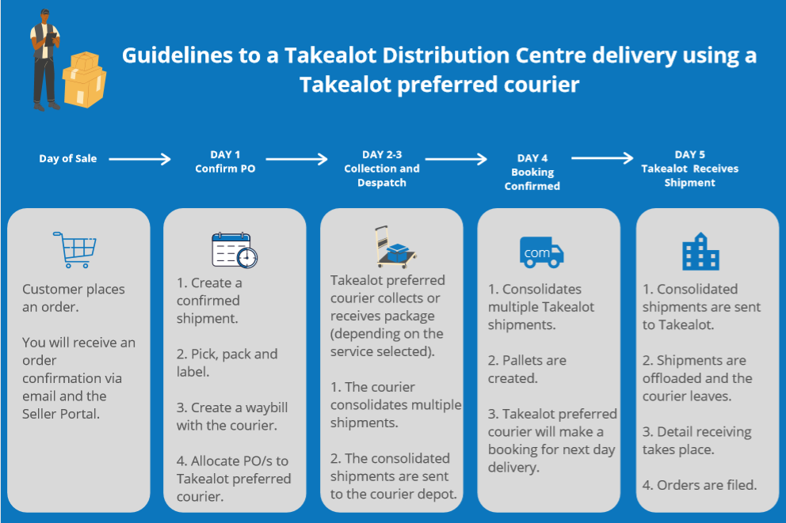
Customers need to add an extra day to our stipulated delivery times (excluding the day of collection)

- OVN – 2 days

- ECO – 3 to 4 days

- AIR – 2 to 3 days

Preferred Courier need to have the actual shipment at our depot to make the booking and to confirm that the shipment is ready for delivery to Takealot.

Added Shipping Labels MUST be done by the customer

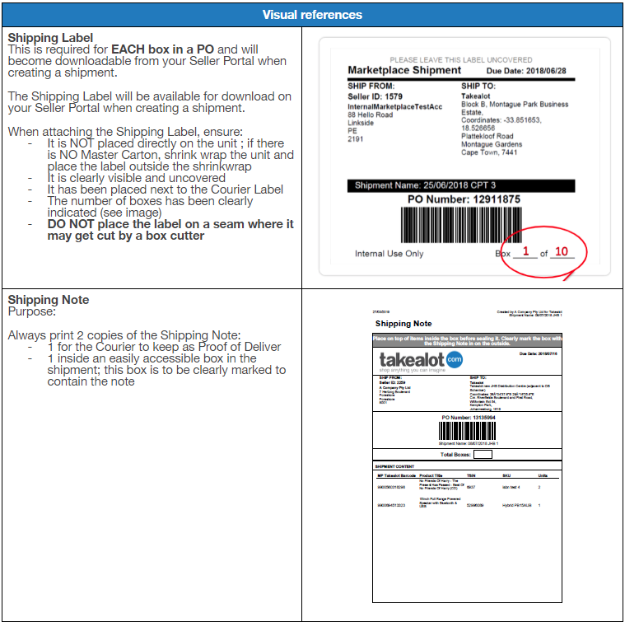

Multiple POs in a master carton. Takealot DCs NOR TCG are not responsible for sorting POs in a carton and therefore reserve the right to reject. Ensure all cartons are marked and labelled correctly

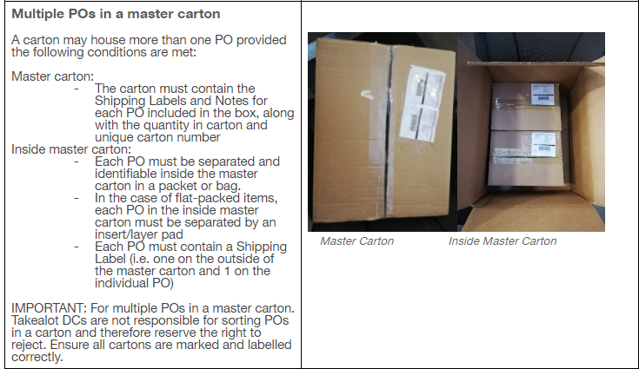

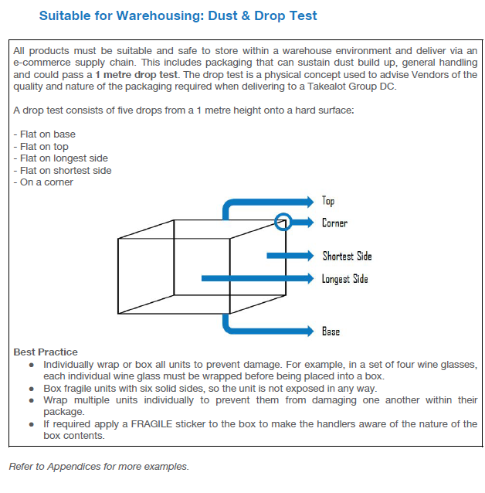

Primary contact

Cape Town

Shana@thecourier.co.za (Deliveries)
samantha.b@thecourierguy.co.za (Manager)

Johannesburg

Precious.m@thecourierguy.co.za (Deliveries & Team Leader)
Genichia@thecourierguy.co.za (Manager)

